第六篇 综合实践课例
人性的光芒，生命的绝唱
---- 英语文学评论教学设计 The fault in our stars
江苏省南菁高级中学 薛海燕
1. 课标呈现
主题语境：人与自我——生命的意义与价值
语篇类型：文学评论（选修：提高类）
语言知识：掌握文学评论的语篇知识；赏析经典台词。
文化知识：价值观念的碰撞：生命的终结不是悲剧的终点，生命的意义在于它的宽度
语言技能：通过文本、图示、音像等方式学习和理解文学评论，促进理解性技能；通过讨论与疾病、死亡相结合的人生主题，促进表达性技能。
学习策略：元认知策略（联系教材文学评论语篇，完成理解或表达任务，反思和巩固所使用的有效的理解或表达的策略）、认知策略（分析文学评论类篇章的典型结构，解释作者如何通过特定的结构来传递意义并达成目的；有效地对所获取的信息进行筛选、分类、重组等，扩展知识并为创建新篇章奠定基础）、交际策略（监控交际中语言运用的得体性，并根据需要做出相应调整）和情感策略（通过多模态的素材，激发英语学习兴趣，主动参加各种学习和运用语言的实践活动，不断增强学习的自信心）等

2. 教学引导
（1）核心素养
《普通高中英语课程标准（2017年版）》（以下简称《课标》）的内容要求提出，“文学阅读有利于提升学生的思维品质和文化品格。”；“教师和教材编写者要关注文学性和非文学性语篇的比例，要确保一定比例的文学性语篇。”
作为文学性语篇的书评，即介绍并评论书籍的文章，是应用写作的一种重要文体，《牛津高中英语》教材模块八第一单元reading部分包含书评。书评是以“书”为对象，实事求是地、有见识地分析书籍的形式和内容，探求创作的思想性、学术性、知识性和艺术性，发挥着信息功能、中介功能和导读功能，从而在作者、读者之间构建信息交流的渠道。《课标》指出，“教师要在教学中注意引导学生观察和分析具体语篇的结构及语言特征，即关注语篇的各个组成部分以及语篇所用的语言是如何表达意义的，避免单纯地讲授语篇知识。”
（2）文本分析
这是一篇书评（book review），介绍美国作家约翰·格林（John Green）所著青春文学作品The Fault in Our Stars，书名引自莎士比亚的戏剧台词，中文译本书名《无比美妙的痛苦》出自女诗人艾米莉·狄金森的诗歌《有一种斜落下来的幽光》。作者用一个穿透生死的故事，讲述了一个简单的道理：爱比死亡更长久，痛苦远远无法超越爱情的伟大。主人公是一对癌症晚期的少年，Hazel借助一个小小的氧气瓶才能在这世间呼吸，Augustus是一个执着于青史留名却只能在游戏世界驰骋的独腿男孩。他们相识于生命旅程的末段，但并不妨碍在这星空留下他们独有的光亮，生命的终结不是悲剧的终点，生命的宽度才是我们追寻的意义本身。
授课时长：1课时（45分钟）
（3）学情分析
授课对象是江苏省南菁高级中学高三年级的某班学生。学生英语基础较好，具备一定的文学鉴赏能力和跨文化意识，参与热情较高。学生从高一起就广泛阅读英语文学名著，但是对于文学评论形式了解不多。大多数学生能够用英语自信地表达自己的观点，但是对于疾病、生死、生命的意义这样的主题接触不多，词汇量和表达有限，需要教师搭建支架引导。
（4）教学目标
经过本节课的学习，学生能够：
1）掌握书评的一般写作方式，思考“You don’t read a great book; it reads you.”（伟大的书从来都不是你在读它,而是它在读你。）；
2）理解故事梗概，寻找本书两位主人公对于“good life”的不同理解，体会小说的主题；
3）讨论“Apparently, the world is not a wish-granting factory.”（显然，世界不是实现愿望的工厂），感悟主人公不幸身患癌症仍要过好当下的勇气，学会更加珍视身边的人。
（5）教学方法
1）主题情境导入；
2）小组讨论；
3）角色体验；
4）呈现、互动评价。
（6）重点或难点
1）书评的语篇结构；
2）疾病、生死、生命意义等表达的习得和输出。
3. 实例举要
Step 1 导入——讨论Coco(《环游寻梦记》)的观影感
Show 4 pictures from the movie Coco, and have a free talk with students.
T: What are the main characters in this movie？
S₁: Miguel, a 12 year-old Mexican boy; Ernesto de la Cruz, his idol; Hector, a down-on-his-luck skeleton (Miguel’s real great-great-grandfather).
T: Can you call back on its plot?
S₂: The story follows a 12-year-old boy, Miguel, who is crazy about music and accidentally transported to the Land of the Dead, where he seeks the help of his deceased musician great-great-grandfather to return him to his family among the living.
T: What can you learn from this movie?
S₃: When you are keen on music or some other hobbies, just go for it and make every effort to live up to your dreams.
S₄: The way we treated their dead relatives in the movie inspires me to cherish the happy moments with our families.
S₅: Be confident of your own talents and brave to seek your future.
T: Great! I’d like to introduce you this week’s movie The fault in our stars, not watching the movie directly but in a different way.
[设计意图] 认知图式认为发展是个体在与环境不断地相互作用中的一种建构过程，其内部的心理结构是不断变化的，而图式正是人们为了应付某一特定情境而产生的认知结构，是一种思维或动作模式。这里教师首先用Coco激活学生的已有图式，因为这部影片包括将要学习的文本相似的语言知识、文化背景、思维能力等，让学生在熟悉的话题和语言环境中，实施主题热身、语言热身、情感热身，缩短师生心理差距，缩短文本和学生之间的差距。
核心素养提升点：学习能力：链接生活，讨论已知，引发新知。
Step 2: 介绍书评文体特征——宏观把握语篇结构、微观了解段落内容
Read the passage and work in groups to complete the form with the help of the following chart.
Theme (P3-4)
- dreams and ambitions
Good life is______________
_______________________
- desire and concept
Suffering_______________
The joy of living_________
Book Review
Title:______________________________
Author:____________________________
Introduction (P1)
- Story
____________________
____________________
- Brief comments
____________________
____________________
Plot (P2)
who___________________
when__________________
what__________________
where_________________
how___________________
Comments or
Recommendation (P5)
___________________
___________________
Group work report:
Group 1
Title: The Fault in Our Stars
Author: John Green
Story: The Fault in Our Stars is a young adult romance of Hazel Grace and Augustus Waters, which gives you the concept of what cancers are like, of how children in particular fight them, reveals and reminds you of your most innocent first love in life.
Brief comments: In this book, you can find a great deal of excitement, humor and a bunch of interesting other stuff.

Group 2
Who: Hazel Grace and Augustus Waters
When: in their teens
What: fighting against terminal cancer but seeking support, love and joy of life at the same time.
Where: in the Support Group, hospital and else where
How: painful but joyful

Group 3
The concept of Good life is divided between Hazel and Augustus. Augustus desires to leave a mark on the world, seeking for glories and meanings of life, fearing most oblivion. On the contrary, Hazel cares less about recognition, but pursuing the act of noticing and loving and sharing.
Suffering: The pain demands to be felt, but how long it should take us to give sufferings a break is subject to be viewed personally.
The joy of life: friendship, hope, love and support from family and friends

Group 4
Comments: Funny, romantic, unputdownable and profound, The Fault in Our Stars is definitely one of the best young adult fiction books in the century. In here some will find humor, some will find encouragement, and some will find a book as a bond for a new love story.
[设计意图] 语篇研读就是读者对语篇的主题、内容、文体结构、语言特点、作者观点等进行深入的解读。以上活动围绕以下三个层面进行：what：语篇的主题和内容是什么；why：语篇的深层含义是什么？作者的意图、情感态度、价值观什么？how：语篇具有什么样的文体特征、内容结构和语言特点。
核心素养提升点：思维品质：思维导图使隐性的语言显性化，小组活动和呈现，引领学生厘清了语篇结构，理解了文章内容，梳理了人物关系，挖掘了文本主题。
Step 3: 开放式讨论——理解文本内涵
T: After constructing the book review, how do you understand “You don’t read a great book; it reads you.”?
S₁: Great books can not only benefit personal growth but also reveal a different but existent world to you. Take this book for an example. You don’t have to suffer terminal cancer like Hazel and Augustus until you find that some people are forced to confront death in a way that you can hardly imagine.
S₂: Thus, reading provides a bridge to understanding and sympathy. At the same time, Augustus may arouse your reflections by his concept of importance. That is, without doing something dramatic that lives in people's minds, will your significance, like your consciousness, simply be consumed by oblivion after death?
S₃: In conclusion, books can not only provide you with a world of different experiences but “read” your understanding, reflections, acts and explorations in the meaning of life.
T: Well done!
[设计意图] 学生要能够理解语篇所表达的意思和意图，关注语篇的内涵意义、价值取向等。从文学作品的阅读共性审视语篇内容到文化现象，强调对语篇的理解要深入到价值观念领域。
核心素养提升点：学习能力：书评激发读者阅读作品的兴趣，讨论文学作品的阅读方式，提升学生的鉴赏能力。
Step 4: 对比阅读——思考、感受生命的意义
If you were discussing with Hazel and Augustus over “what is good life”, reveal different understandings.
Hazel
Augustus
seeing__________
fearing_____________
caring __________
leaving _________
Good
life
_______
Who do you support?
S₁: I support Hazel. Caring not about recognition, she sees heroism as an act of noticing and loving and sharing.
S₂: In a gesture to leave a mark on the world, Augustus seeks for glories and meanings of life, fearing most oblivion. I want to find myself a place in this world and hope to be remembered for my achievements in the future.
S₃: I find both are acceptable. Surrounded by family and friends who love me, I have courage and inspiration to make my dreams come true.
[设计意图] 站在角色的立场讨论自己的生活，学生产生深重的认同感，要面对人性中真实的一面，害怕、绝望无济于事，倒不如活在当下，珍惜家人和朋友，把每一天都当作生命中的最后一天来珍惜。
核心素养提升点：思维品质：对比阅读与角色体验式的活动不仅让学生深度挖掘了文本中所隐含的意蕴，帮助学生汲取了文化的精华，也影响了其行为取向。
Step 5: 教材链接——类比阅读后仿写，加深语篇理解
T: How to write a book review successfully? (小组讨论，引导、归纳并呈现以下书评写作体例)
- giving a general introduction
- combing the plot
- exploring the theme
- making comments
请参考step 2的思维导图完成Great Expectations的材料收集，仿写一篇书评，要点包括：
1. 简要介绍作品情况
2. 叙述作品故事情节
3. 挖掘作品主题意义
4. 评论作品推荐阅读
Great Expectations is set in _______________________________________________
_______________________________________________________________________________________________________________________________________________________________________________________________________________
范文：
Great expectations is set in England in the early 1800s. The author uses Pip, the main character, to tell the story. Having lost his parents, Pip lives with his older sister and her husband Joe. Pip’s sister often abuses him, but Joe is a kind and simple man who would rather die than see any harm come to Pip.
Pip, who is seven years old when the story begins, is in a foggy cemetery when a desperate criminal appears and frightens him. Mist is a symbol of danger in Great Expectations. Classic novels often have symbols which add interest, tension or deeper meaning to the text. Readers may not be able to see the danger, so they need a symbol like the mist to make it clearer to them.
There is a twist in the plot when a very generous stranger gives Pip a large fortune. As a condition for receiving this fortune, Pip must move to London and begin the life of a gentleman. Pip is eager to begin his new life. Money and education, however, change him, and before long he becomes vain and ashamed of his background. Pip dislikes it when Joe comes to visit him in London. He has rigid ideas of what it means to be civil and to be a gentleman, and is embarrassed by Joe because he does not fit these.
Pip is bent on becoming a gentleman and winning Estella’s love. Estella is a beautiful girl, and for Pip she a symbol of education and money. What is really means to be a gentleman is an important theme in Great Expectations. Is a person with a lot of money a gentleman? Or, is a gentleman somebody who is kind and good to his friends?
By the end of the noble, Pip has changed a lot. He learns that wealth does not buy happiness and that friends are more important than a fancy education. This change in Pip is called character development, which is an important part of almost any novel. Does Joe forgive Pip? Does Pip get the girl of his dreams? Will Pip ever find out the identity of the person who gave him the money? You will just have to read the great book yourself to find out. (摘自《牛津高中英语》模块八第一单元reading部分)
[设计意图] 链接的文学评论写作目的培养学生的该文体的研读能力，并进一步帮助学生从读到写，更有效地把握学习内容，也提升其对教材的再认知。
核心素养提升点：思维品质：从读懂语篇迁移到建构新语篇，学生不断更新自己的认知结构，实现思维从低阶向高阶的稳步发展，不断获得语篇阅读的新策略、新技能。
Step 6: 视野拓展——赏析原著改编电影中的经典台词

由《无比美妙的痛苦》改编的电影恢复了原著的译名《星运里的错》，由约什·布恩导演，谢琳·伍德蕾，威廉·达福，劳拉·邓恩等主演，原著的经典台词在电影中得到精彩演绎，值得赏析回味：
1. I fell in love with him the way you fall asleep: Slowly, and then all at once. （我以入睡的方式爱上了他：开始慢慢的，然后一下子。）
2. I am in love with you. And I know that love is a shout into the void, and oblivion is inevitable. And we're all doomed. And that one day, all of our labors will be returned to dust. And I know the sun will swallow the only Earth we will ever have. And I am in love with you.（我爱上你了，我知道爱只是虚空里的呐喊。遗忘在所难免，我也知道我们都在劫难逃，总有那么一天，我们的努力将重归于土。我还知道太阳会吞噬我们唯一的地球，但我还是爱上你了！抱歉。）
3. Pain demands to be felt. （痛苦要求被感觉到。）
4 I will not indulge your childish whims. I refuse to pity you in the manner in which you are accustomed.（我不会纵容你去没头没脑的胡思乱想。我也不会给你你所习惯的怜悯。）
5. Of course you do！Like all sick kids, your existence depends on it. You are fated to live out your days as the child you were when diagnosed. A child who believes there’s a life after when a novel ends. …You are a side effect to an evolutionary process that cares little for individuals. You are a failed experiment in mutation.（你当然想要！就像所有患病的孩子，你就指望着它过日子。你们注定要停留在你们不治之症确诊出来的那个年纪，相信小说结束生命还能延续。你们只是进化过程中忽视个别生命而产生的次品。你们只是实验突变中的失败案例。）
《 华尔街日报》对此影片评论到：这部青春电影最难能可贵的地方在于，它展示的是一个严肃而充满痛苦的主题，但角色却并没有给人带来压抑感，女主角的幽默尤其让人温暖。
[设计意图] 台词、电影都是学生特别喜欢的学习方式，不仅促进学生的主动学习，而且还能激发学生的深度思考。
核心素养提升点：学习能力：课堂逐渐延伸到课外，书本延伸到多模态素材，充分提升学生的学习能力。
4. 评析通鉴
在本课例中，笔者践行了日本教育家佐藤学的教师必须成为“学习行为的设计者”这一理念。在对本班学生的学习需求进行分析的基础上，笔者了解到学生想做什么、能做什么、该做什么。
“想做什么”是指学生的爱好和兴趣，包括对学习活动的主题、语篇、文化知识等方面。美国作家约翰·格林（John Green）所著青春文学作品The Fault in Our Stars是一部坚韧、感人的爱情小说，能充分激发学生的阅读兴趣，与疾病、死亡相结合的人生主题虽然有些沉重，但语言知识和文化知识的难易度符合高中学生年龄的特点，不仅他们已经对这样的主题有能力思考，更是能从本书的讨论中获得认知的角度，看问题的方法和不一样的文化体验，不仅能帮助学生汲取文化的精华，也影响其行为取向。
“能做什么”涉及学生已有的认知结构和能力水平，包括语言、文化、思维、学习等方面的知识和能力。对于这个穿透生死的故事，学生对文本传达的道理：爱比死亡更长久，痛苦远远无法超越爱情的伟大，是能够理解的，但是相关疾病、死亡、生命的意义等的主题词语和文化背景，根据学生的认知特点和学习习惯，笔者搭建适当的、适合的建构框架。
“该做什么”指的是学生应该要提高的关键能力和必备品格，具体可以分为学生的共性需求和个性需求。学生的共性需求主要体现对学生英语学科核心素养的各级水平有一个整体上的理解和把握，并从主题、语篇、知识（包括语言知识和文化知识）、技能和策略六要素的角度解读The fault in our stars, 笔者根据《课标》相关的内容要求和教学提示，设计符合学生最近发展区的综合性语言实践活动；个性需求的分析了解个体能力，作为教学的起点激励学生形成内在驱动，学生为弥补自身不足而主动学习乃至“选择性学习”，原本被动的阅读就成了学生语感、语会和语用的活动场和示范本。
笔者对文本的处理从“碎片化”转向“整合化”，实现了补充教材与语文学科、牛津教材之间的链接，通过丰富多维的活动让师生让学生“走心”地主动学习、选择性学习，确保学生以“学”为核心。笔者基于学情，引导学生获取、整合、内化文本信息，学会发现问题、分析问题和解决问题，在流程性活动中发展学生的语言能力和学习能力，提升了思维品质，逐步形成文化意识。
5.思维地图
（1）利用思维地图（Thinking Maps）中的树状图（Tree Map）解读执教者《课标》所呈现的思维理念：
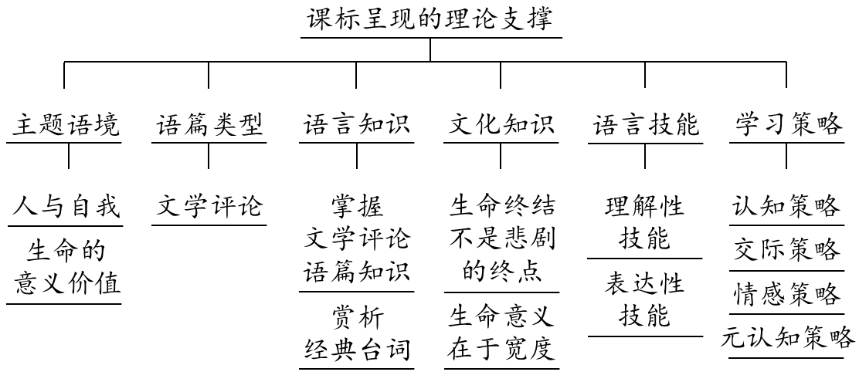
（2）利用思维地图（Thinking Maps）中的树状图（Tree Map）解读执教者进行教学引导的思维理念：
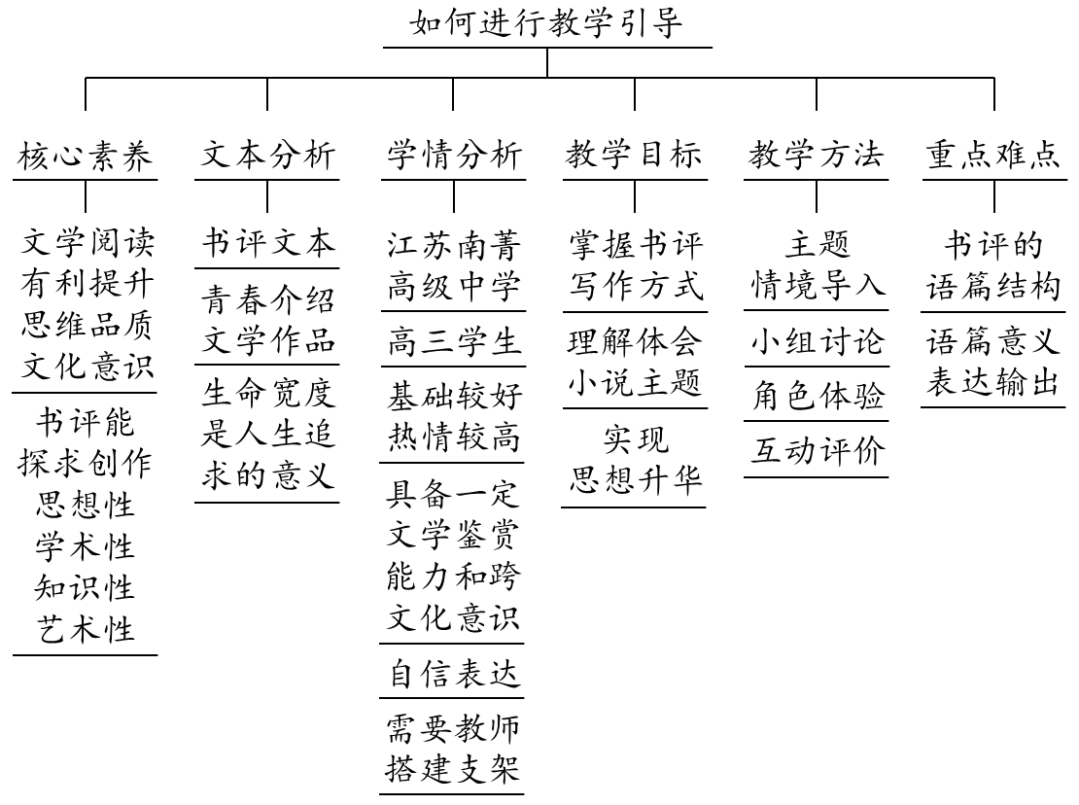
（3）利用思维地图（Thinking Maps）中的复流程图（Multi-Flow Map）解读执教者在Step 1环节的教学思维理念：
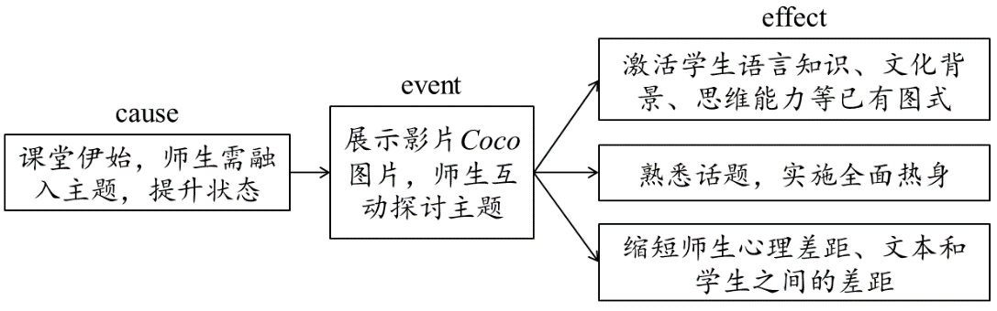
（4）利用思维地图（Thinking Maps）中的桥状图（Bridge Map）解读执教者在Step 2环节的教学思维理念：
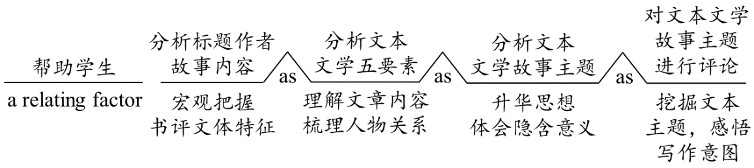
（5）利用思维地图（Thinking Maps）中的复流程图（Multi-Flow Map）解读执教者在Step 3环节的教学思维理念：
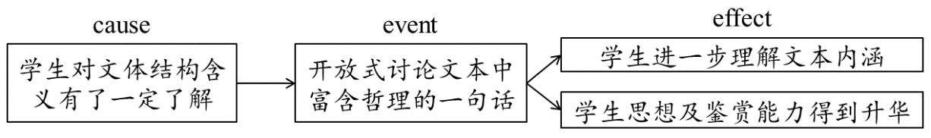
（6）利用思维地图（Thinking Maps）中的复流程图（Multi-Flow Map）解读执教者在Step 4环节的教学思维理念：
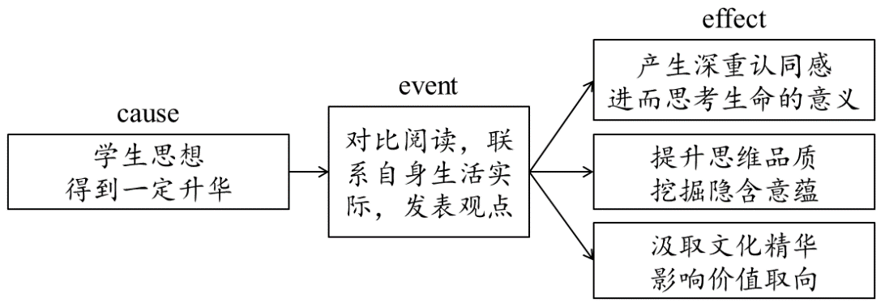
（7）利用思维地图（Thinking Maps）中的复流程图（Multi-Flow Map）解读执教者在Step 5环节的教学思维理念：
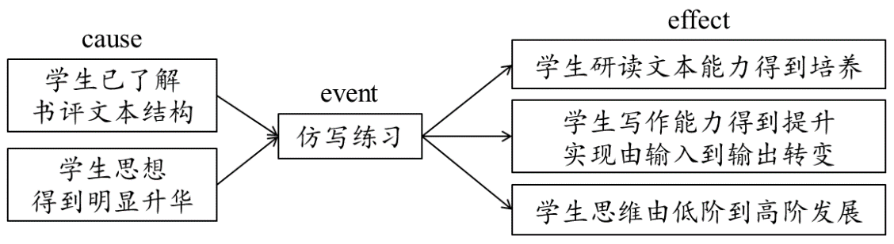
（8）利用思维地图（Thinking Maps）中的复流程图（Multi-Flow Map）解读执教者在Step 6环节的教学思维理念：
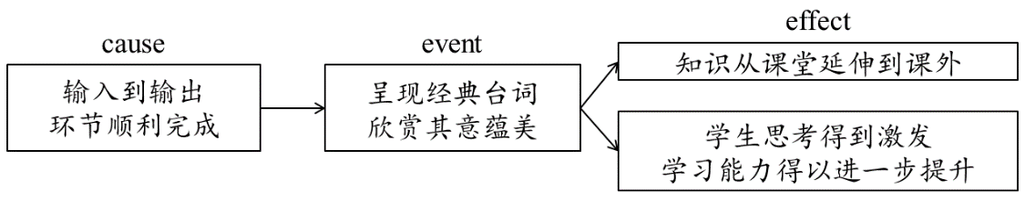

参考文献：
[1] 教育部. 2018. 普通高中英语课程标准（2017年版）[M]. 北京：人民教育出版社.
[2] 梅德明，王蔷. 2018. 普通高中英语课程标准（2017年版）解读[M]. 北京：高等教育出版社.

注：文中课例的部分内容选自于笔者The fault in our stars一文，刊于《疯狂英语》2018(12).

附：文本原文

The Fault in Our Stars
If you read The Fault in Our Stars only to find a young adult romance of Hazel Grace and Augustus Waters, then you definitely underestimate the power of sophisticated symbolism, emotions, and literature John Green offers. I remember someone saying “You don’t read a great book; it reads you.” The Fault in Our Stars is one of those books. It gives you the concept of what cancers are like, of how children in particular fight them, reveals and reminds you of your first love in life, always the youngest and the most innocent. I will resist my urge to tell you the plot and spoil the whole story, but I promise you every single page here is worth a great deal of excitement, humor and a bunch of other stuff listed down here which I think are interesting.

The book gives lives to where we find deaths. The joy of living comes in when terminal cancer is nothing more than just “a side effect of dying”, when you can laugh in the misfortunes of disease and say “I’m on a rollercoaster that only goes up, my friend.” The Fault in Our Stars, however, starts with Hazel’s “depression” like many of us start a new day. Thus, Hazel’s mother wants her cancer-stricken daughter to have a life, putting her in the Support Group. Later on, Issac and Augustus give her hope and something to believe in. The friendship tied by the shared intellectual curiosity and dreams. The story is so carefully plotted that even though Hazel doesn’t go to school like other kids, her life is so in touch with ours. Everyone in a while will feel as if everything goes wrong, that it sucks at being what it’s supposed to be. Bad grades, getting dumped, or even having a terminal disease. “The pain demands to be felt.” But after all, how long should it take us to give sufferings a break is subject to be viewed personally, since it would determine whether or not we become a type of Peter Van Houten, Hazel’s favorite writer in the novel.

John Green also cares about your dreams and ambitions. As you read through chapters, especially toward the end, you will find out Hazel and Augustus have widely different ideas of what they think is a “good life”. Here I find a reflection of my soul in Augustus’s, with all his desire to leave a mark on the world. Such a guy he is seeking for glories and meanings of life, fearing most oblivion. Others may find themselves, in contrast, caring not about recognition. They are like Hazel Grace, seeing heroism as an act of noticing and loving and sharing. Both ideas are beautiful and proofed to be fearless to be together despite any mental or physical challenges lying on their way to the pursuit of happiness.

“Apparently, the world is not a wish-granting factory.” The book embraces the restless, innocent desires of young minds. Would you care for a trip to Amsterdam when you’re at the 4th stage of cancer to find out what happens after the end of your favorite book? Would you dare to love the dying, to be okay to love when you’re dying, or to forgive yourself for hurting those who love you in case you die? In the book, you will find John Green mentions about how “some infinities are greater than other infinities,” which means, I think, can be defined, expanded and shrunk. Infinities are created by taking chances, and if we fail while doing so, then the fault is simply in our stars, not ourselves.

Funny, romantic, unputdownable and profound, The Fault in Our Stars is definitely one of the best young adult fiction books in the century. It may touch the readers in many different ways. In here some will find humor, some will find encouragement, and some will find a book as a bond for a new love story. But if you insist that you only want to read a good love story in The Fault in Our Stars, that’s fine too. It’s an excellent book that reminds us of those who are important.

